QUESTION 1.

#include<stdio.h>

int main()

{

int a, b, great;

printf("Enter first number: ");

scanf("%d" , &a);

printf("Enter second number: ");

scanf("%d", &b);

if(a>b)

great=a;

else

great=b;

printf("\nGreatest of the two number is: %d", great);

return 0;

}

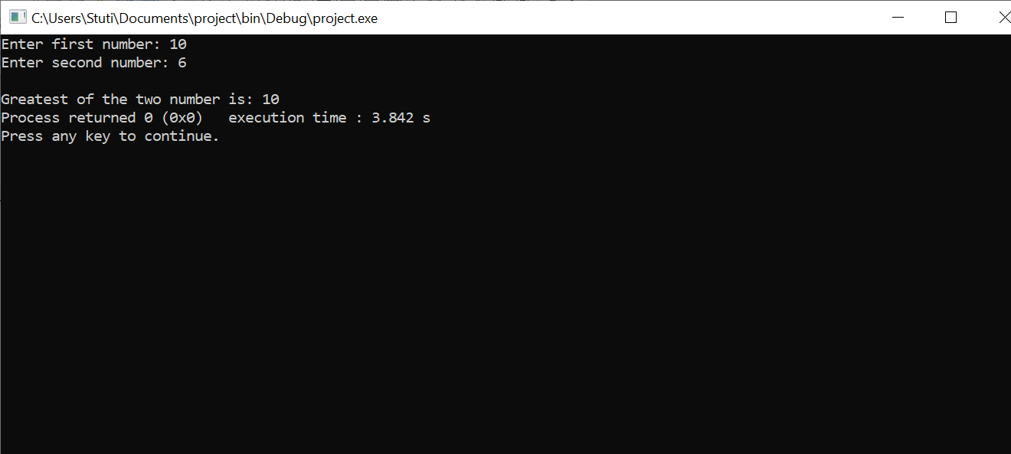

QUESTION 2 .

#include <stdio.h>

int main()

{

int num;

printf("Enter a number \n");

scanf("%d", &num);

if (num >= 0)

printf("%d is a positive number \n", num);

else

printf("%d is a negative number \n", num);

return 0;

}

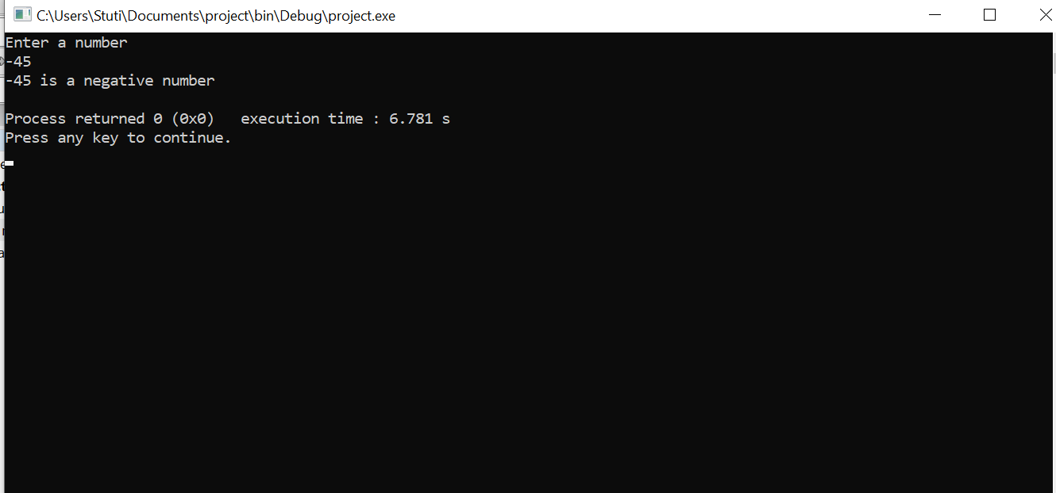

QUESTION 3 .

#include <stdio.h>

int main()

{

int num;

printf("Enter an integer: ");

scanf("%d", &num);

if(num % 2 == 0)

printf("%d is an even number.", num);

else

printf("%d is an odd number.", num);

return 0;

}

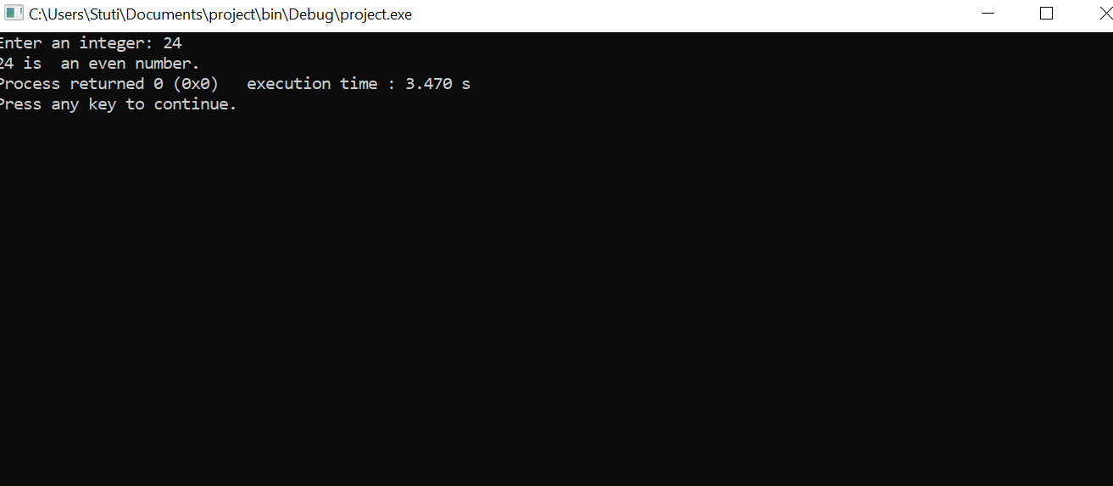

QUESTION 4.

#include <stdio.h>

int main()

{

char ch;

printf("Please Enter an alphabet: \n");

scanf(" %c", &ch);

if(ch == 'a' || ch == 'e' || ch == 'i' || ch == 'o' || ch == 'u' ||

ch == 'A' || ch == 'E' || ch == 'I' || ch == 'O' || ch=='U')

{

printf("\n %c is a VOWEL.", ch);

}

else

{

printf("\n %c is a CONSONANT.", ch);

}

return 0;

}

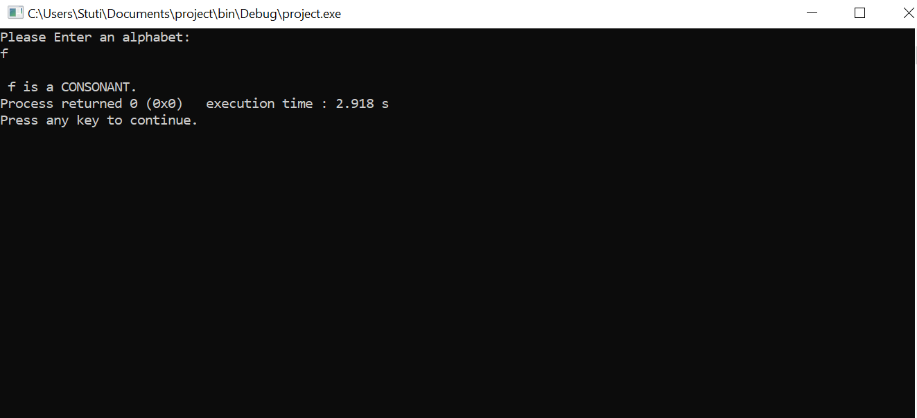

QUESTION 5.

#include<stdio.h>

int main()

{

int age ;

printf("Enter the age of the person: ");

scanf("%d",&age);

if (age>=18)

{

printf("Eligible for voting");

}

else

{

printf("Not eligible for voting\n");

}

return 0;

}

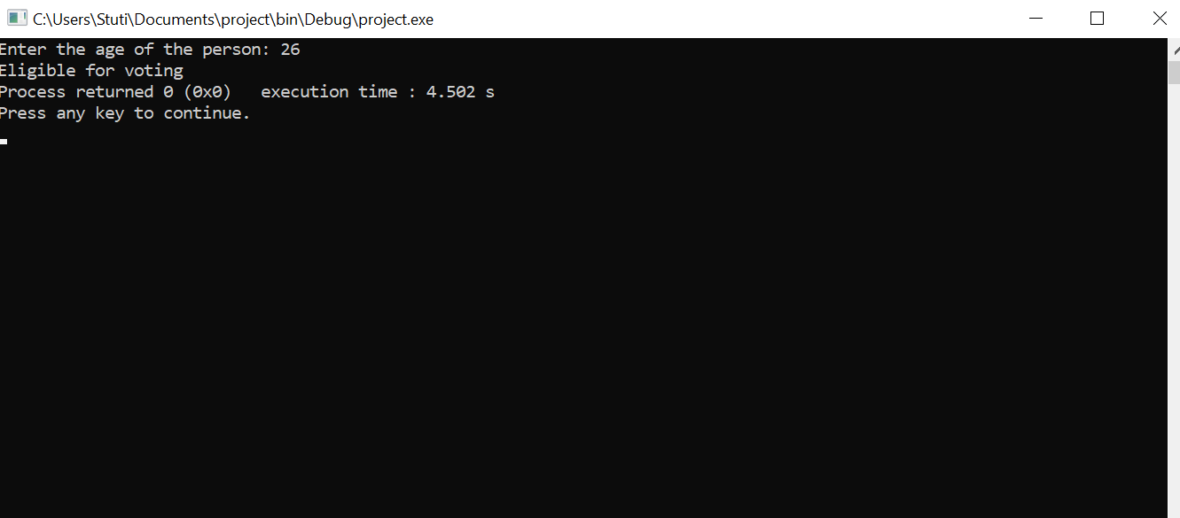

QUESTION 6.

#include <stdio.h>

int main()

{

int year;

printf("Enter a year: ");

scanf("%d", &year);

if (year % 400 == 0)

{

printf("%d is a leap year.", year);

}

else if (year % 100 == 0)

{

printf("%d is not a leap year.", year);

}

else if (year % 4 == 0)

{

printf("%d is a leap year.", year);

}

else

{

printf("%d is not a leap year.", year);

}

return 0;

}

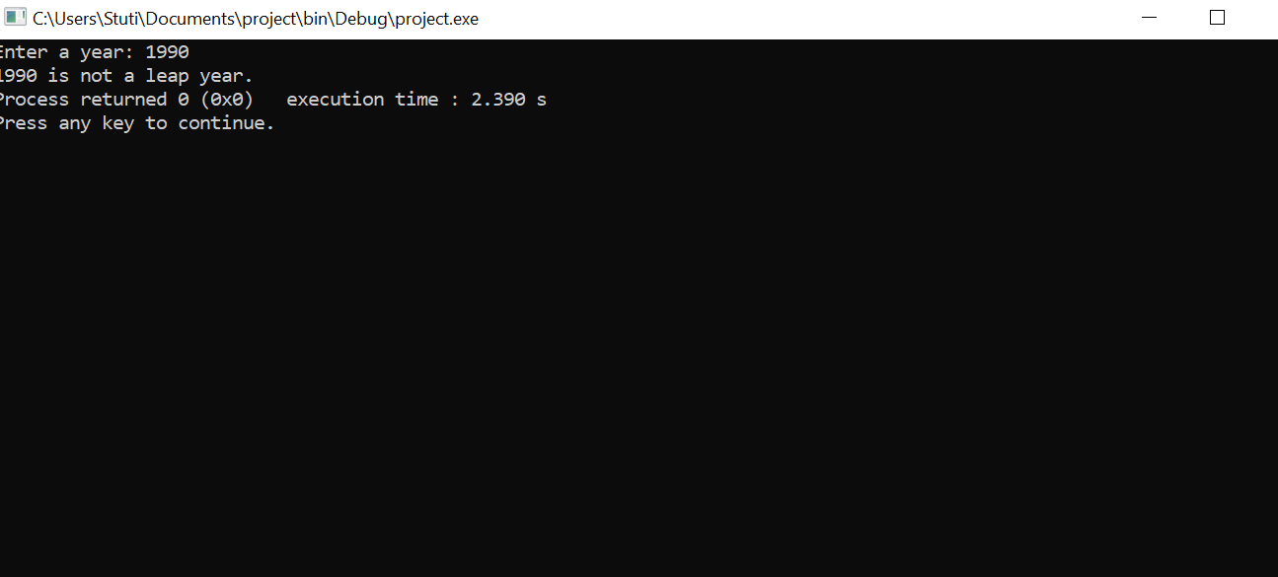

QUESTION 7 .

#include<stdio.h>

int main()

{

int num1,num2,num3;

printf("\nEnter value of num1, num2 and num3:");

scanf("%d %d %d",&num1,&num2,&num3);

if((num1>=num2)&&(num1>=num3))

printf("\n Number1 is greatest");

else if((num2>=num3)&&(num2>=num1))

printf("\n Number2 is greatest");

else

printf("\n Number3 is greatest");

return 0;

}

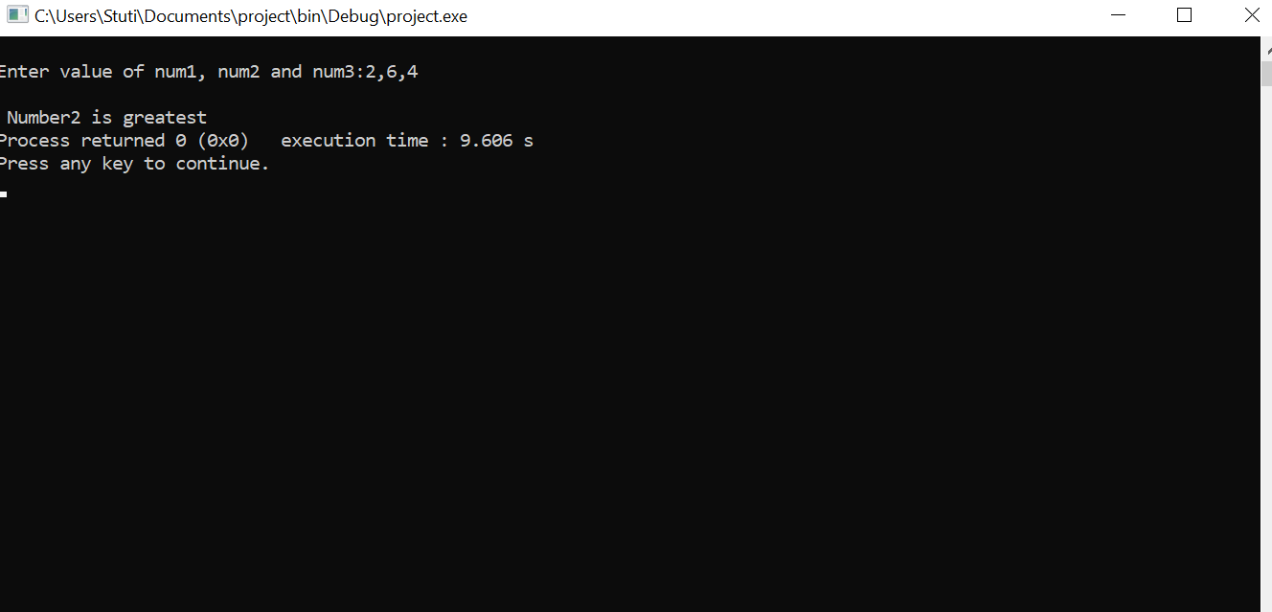

QUESTION 8.

#include<stdio.h>

int main()

{

int s1,s2,s3,s4,s5,total=500,sum=0;

float per;

printf("Enter Marks of 5 Subjects: ");

scanf("%d%d%d%d%d",&s1,&s2,&s3,&s4,&s5);

sum=s1+s2+s3+s4+s5;

printf("Sum of 5 Subjects is: %d\n",sum);

per=(sum\*100)/total;

printf("Percentage is: %f",per);

if(per >= 90)

{

printf("Grade A");

}

else if(per >= 80)

{

printf("Grade B");

}

else if(per >= 70)

{

printf("Grade C");

}

else if(per >= 60)

{

printf("Grade D");

}

else if(per >= 40)

{

printf("Grade E");

}

else

{

printf("Grade F");

}

return 0;

}

QUESTION 9.

#include <stdio.h>

int main()

{

int amount;

int note500, note100, note50, note20, note10, note5, note2, note1;

note500 = note100 = note50 = note20 = note10 = note5 = note2 = note1 = 0;

printf("Enter amount: ");

scanf("%d", &amount);

if(amount >= 500)

{

note500 = amount/500;

amount -= note500 \* 500;

}

if(amount >= 100)

{

note100 = amount/100;

amount -= note100 \* 100;

}

if(amount >= 50)

{

note50 = amount/50;

amount -= note50 \* 50;

}

if(amount >= 20)

{

note20 = amount/20;

amount -= note20 \* 20;

}

if(amount >= 10)

{

note10 = amount/10;

amount -= note10 \* 10;

}

if(amount >= 5)

{

note5 = amount/5;

amount -= note5 \* 5;

}

if(amount >= 2)

{

note2 = amount /2;

amount -= note2 \* 2;

}

if(amount >= 1)

{

note1 = amount;

}

printf("Total number of notes = \n");

printf("500 = %d\n", note500);

printf("100 = %d\n", note100);

printf("50 = %d\n", note50);

printf("20 = %d\n", note20);

printf("10 = %d\n", note10);

printf("5 = %d\n", note5);

printf("2 = %d\n", note2);

printf("1 = %d\n", note1);

return 0;

}

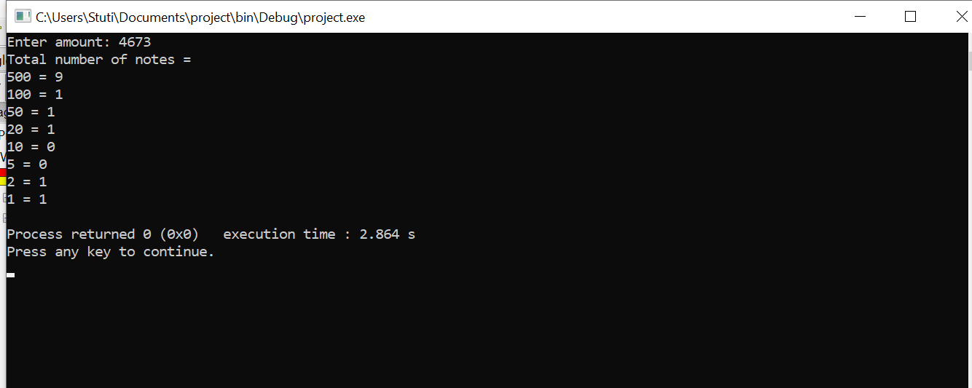

QUESTION 10.

#include <stdio.h>

int main()

{

float basic, gross, da, hra;

printf("Enter basic salary of an employee: ");

scanf("%f", &basic);

if(basic <= 10000)

{

da = basic \* 0.8;

hra = basic \* 0.2;

}

else if(basic <= 20000)

{

da = basic \* 0.9;

hra = basic \* 0.25;

}

else

{

da = basic \* 0.95;

hra = basic \* 0.3;

}

gross = basic + hra + da;

printf("GROSS SALARY OF EMPLOYEE = %.2f", gross);

return 0;

}

